User’s Manual For SPANGLES

1 Setup

This program needs a web server and all of the source code and additional libraries that are already included. The additional libraries are in the directory “dependencies” (Vector.js) and in “lib” (WebCGF). There is also PROLOG code in “prolog” that needs to be run with SICSTus Prolog, by consulting the file **server.pl** and calling the function server(), by typing **server.** in the console of SICStus.

2 Game rules

SPANGLES rules are pretty simplistic. After the first triangle is placed anywhere on the empty board, the next ones need to be placed adjacently to the triangles that are already on the board. The game ends when there is no space to make moves or when one of the players creates a triangle that is composed with four triangles of his own color (2 triangles height, 2 triangles width and one triangle in the middle).

3 User Instructions

After all the setup is completed and the program is running, a board is displayed along with a score board and an interface. The interface serves as the game management and settings. In the first dropdown, the user can start a new game against a human player or against a bot (artificial intelligence) and undo a move made. After this menu, the settings of the game are shown and the players can change the difficulty of the bot, the duration of a turn (up to30 seconds) and the size of the board (up to 15). Finally, the player can also change the ambient he’s in, having two additional scenes besides the current one.

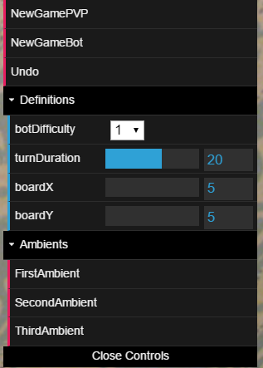

Figure 1: Interface

The first player that starts the game is always the one with the yellow piece. After he places the first piece it is the second player turn and he makes his move, and so on. These moves are made by clicking on the position of the board that the current player would like to place his piece. If the move is not allowed, the piece doesn’t move and the player needs to make a new move. After the game ends, a “movie” of the game starts to play, with all the moves that the players made.

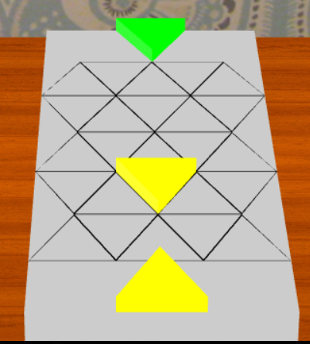

Figure 2: 1st player view

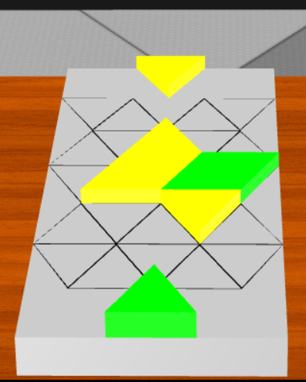

Figure 3: 2nd player view

The player controls the camera by pressing space or the letter “R”. Space cycles between the two players perspectives and “R” shows the player the score board that is on the wall.

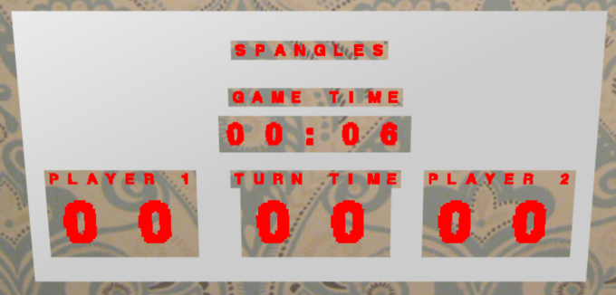

Figure 4: Score Board